LAB ASSIGNMENT V : HUERISTIC EVALUATION
SYSTEM EVALUATED : PharmEasy redesign "Nivara Health" - high-fidelity prototype (screens: Home, Medicine listing, Product details, Cart & checkout)
PART I : HUERISTIC EVALUATION BASED ON NIELSEN'S 10 GENERAL PRINCIPLES FOR INTERACTION DESIGN. (0 is lowest and 10 is highest)
S.No. | Heuristic Evaluation Parameter | Mention Violation if any | Severity 0-10 (0 = lowest, 10 = highest) | Ways to improve
1 | User Control: Interface will allow the user to perceive that they are in control | • Cart: coupon FIRSTCARE is pre-filled and the -Rs15 discount already shows, yet the 'Apply' button is unchanged; no 'applied' state or way to remove the coupon.  • Cart: 'Remove' is a small red text link with no undo. | 4 / 10 | • Show applied state (tick + 'x' to remove coupon).  • Add 'Item removed - Undo' snackbar.
2 | Human Limitations: Interface will not overload the users cognitive, auditory and motor skills | • Secondary text (pack size, breadcrumbs, step tracker 'Cart - Address - Payment', 'Need help?') is ~10-11 px light grey.  • Home links 'Upload prescription / Order from past purchases / Get pharmacist help' are tiny.  • Small touch targets: filter check-boxes and qty +/- buttons. | 6 / 10 | • Min 14 px body / 12 px caption; raise contrast.  • Turn the 3 home links into visible chips/buttons.  • 44 px minimum touch targets.
3 | Accommodation: The interface will fit the way each user group works and thinks (personas) | • Persona (Ananya Roy, caregiver for senior parents) needs refill, prescription upload and delivery tracking, but these are not surfaced: no refill widget, no Rx-attach step in cart, no verification tracker.  • No large-text / elderly mode; no regional-language option. | 7 / 10 | • Add 'Reorder / Refill' card on home.  • Add prescription attach + status step in checkout.  • Offer Large-text mode and Hindi/Marathi toggle.
4 | Linguistic Clarity: Interface will communicate as efficiently as possible | • Most labels are clear (Order Medicines, Book a Lab Test, Proceed to Checkout).  • PDP image thumbnails labelled 'Grip' (meaningless for a medicine pack).  • Nav 'Healthcare Products' vs 'Wellness' overlap; 'Buy Now' vs 'Add to Cart' not explained.  • Same trust claims (genuine / reliable / secure) repeated in 3 places. | 4 / 10 | • Rename to Front / Back / Side.  • Merge or describe overlapping nav items.  • Add helper text 'Buy Now skips the cart'.  • Show trust strip once per page.
5 | Aesthetic Integrity :The interface will have an attractive and appropriate design | • Strong, consistent teal-white palette, rounded cards, good white space, friendly hero photo.  • Orange 'Buy Now' and peach offer cards depart from the palette.  • Listing: first card (Dolo 650) shows a pharmacy-shop photo, not the product pack; image styles/backgrounds vary.  • 'Welcome offer' pill is low contrast. | 4 / 10 | • Use one accent role (teal) for actions.  • Use pack shots on a uniform background.  • Raise pill contrast.
6 | Simplicity: The interface will have a simple design | • Home repeats search (header bar + 'What medicine do you need?' bar).  • Long home page: hero, search, categories, popular, offers, trust band, footer; trust band appears at top, bottom and in cart.  • Positive: only 5 nav items and no pop-ups. | 4 / 10 | • Keep a single search (promote the large one, collapse header search on home).  • Trim repeated trust strips.
7 | Predictability :The interface will behave in such a manner that the user can accurately predict what will happen next | • 'Buy Now' (orange) competes with 'Add to Cart' (teal) as two primary buttons.  • Listing cards offer 'Add to Cart' with no visible post-click behaviour (stepper? drawer?).  • Coupon 'Apply' unclear whether coupon is already active (see 1).  • Positive: primary CTA colour is consistent. | 5 / 10 | • One primary CTA per screen; make 'Buy Now' secondary.  • Replace card button with qty stepper after add.
8 | Accuracy: Interface will be free from errors | • Delivery-fee contradiction: PDP reads 'Free delivery above Rs499' but cart (Rs147.70) shows delivery fee FREE.  • Listing says 'No products require a valid prescription' while home promotes 'Upload prescription'.  • Arithmetic checks out: 31.20 + 131.50 = 162.70; less Rs15 coupon = Rs147.70. | 7 / 10 | • Make the free-delivery rule match the cart logic (or show 'Add Rs X for free delivery').  • Make Rx messaging consistent; add Rx badges on cards.
9 | Technical Clarity: Interface will have the highest possible fidelity. | • High-fidelity look is polished, but PDP thumbnails are empty text tiles (no real alternate views).  • Only 4 desktop screens: no login, address, payment, confirmation, prescription upload or tracking.  • Product imagery inconsistent in scale and background. | 6 / 10 | • Design the missing flow screens.  • Add real gallery images.  • Create a mobile frame set.
10 | Fulfillment : The interface will provide a satisfying user experience | • Core task (find medicine -> product -> cart) takes few steps; 'You save ... on this order' banner is rewarding.  • No visible order confirmation, tracking or refill reminder to close the loop.  • Offer cards show codes (FIRSTCARE, LAB250, WELL10) with no copy / apply action. | 2 / 10 | • Add confirmation + tracking screens.  • Add 'Copy / Apply' on offer cards.
11 | Consistency: Interface will be consistent | • Mostly consistent system (teal solid primary, outlined secondary, same card style).  • Qty stepper differs: plain '- 1 +' on PDP, boxed on cart.  • Red 'Remove' vs green links elsewhere; orange 'Buy Now' off-system. | 4 / 10 | • Document one stepper and one link style in the design system.  • Remove off-palette CTA colour.
12 | User Support: Interface will provide additional assistance as needed or requested | • Help is present but weak: 'Need help? 1800-120-CARE' in tiny grey text; 'Get pharmacist help' tiny link.  • No chat, no tooltips (e.g. on coupons, delivery slot, Rx rules). | 5 / 10 | • Add persistent Help / pharmacist chat button.  • Inline tooltips and a short 'How prescription ordering works' link.
13 | Precision: The interface will allow the users to perform a task exactly | • Filters cover category, price, brand and rating only: no salt/composition, dosage form, pack size or Rx/OTC filter.  • Delivery slot cannot be chosen (only an arrival window); address changed only via link.  • Cards show no salt name, so generics are hard to compare. | 6 / 10 | • Add salt/composition, form and Rx filters; show salt on cards.  • Add delivery-slot picker.
14 | Forgiveness: Interface will make action recoverable | • No undo for item removal; coupon cannot be removed.  • No designed error / edge states: empty cart, invalid coupon, misspelt search, out-of-stock, address error.  • Positive: 'Clear all' filters and removable filter chip. | 7 / 10 | • Design all error and empty states with a recovery action (e.g. generic-salt alternatives for out-of-stock).  • Undo snackbar.
15 | Responsiveness: The interface will inform users about the results of their actions and their interface status | • Good status cues: 'All items in stock', 'Delivery by tomorrow', savings banner.  • No visible add-to-cart confirmation, coupon validation result, loading state, or prescription-verification status.  • Step tracker (Cart / Address / Payment) is tiny and low contrast. | 5 / 10 | • Add toast on add-to-cart and coupon result.  • Enlarge the checkout stepper.  • Add Uploaded -> Reviewing -> Added tracker.
 | Total Score |  | 76 / 150 | Lower is better. Avg severity 5.1 / 10 = moderate.
Scoring: severity 0 = lowest (no problem), 10 = highest (critical); Total is the sum of 15 ratings (max 150). Evaluation is based on the static high-fidelity screens (interactions, mobile and screen-reader behaviour could not be tested).
**Attach Screenshots
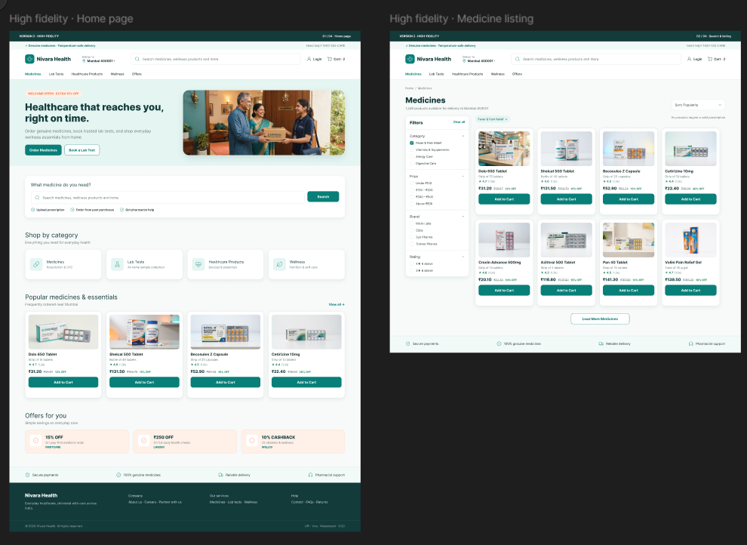
Screenshot 1: Home page (left) and Medicine listing (right) - high-fidelity prototype.
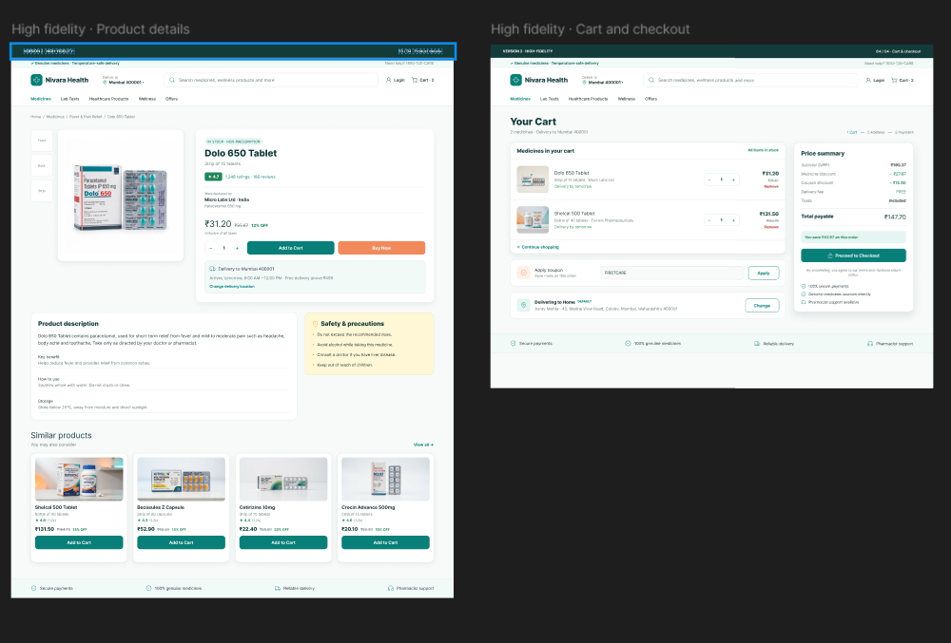
Screenshot 2: Product details (left) and Cart & checkout (right) - high-fidelity prototype.
PART II : List out any other points that you may have missed out . (Other than Nielsen’s Principles)

S.NO | OBSERVATIONS | COMMENTS
1 | Only desktop frames; no mobile / tablet layouts. | Experiment 1 notes the mobile app / mobile web as a main channel; touch targets and 4-column grids need a mobile redesign.
2 | Edge and error states are missing (empty cart, zero search results / misspelt drug, out-of-stock, invalid coupon, loading). | Directly relates to Pain Point 6 in Experiment 2; add generic-salt alternatives on zero-states.
3 | Accessibility cannot be confirmed: light-grey small text, colour-only status (green 'in stock', red 'Remove'), no visible focus states. | Run a WCAG 2.1 AA contrast check; add text/icon cues beyond colour; specify alt text and focus rings in the design spec.
4 | Prescription workflow is under-designed: upload is a tiny link, no Rx badge on cards or PDP, no verification tracker. | Roadmap items 'Prescription Verification Tracker' and 'Express Refill Dashboard' (Experiment 2) are not yet in the screens.
5 | Trust and compliance cues are thin: 'Genuine medicines' text only; no drug-licence / pharmacist registration shown. | Add licence number and pharmacist-verified badge in footer, PDP and cart.
6 | Strengths worth keeping: breadcrumbs, 'Safety & precautions' panel on PDP, price summary with savings, 5-item nav, no pop-ups, max 3 offer cards. | These address Experiment 1/2 issues (clutter, pop-ups, navigation) and should be retained in later iterations.

Students Evaluation Team : group that is evaluation ………………………………………………………………………………..

